**SoundPlay Mobile Application Design Brief**

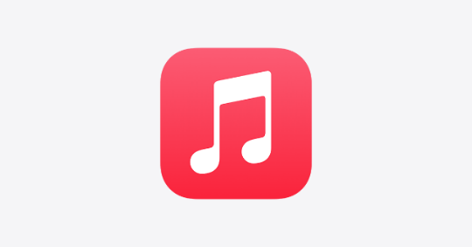

Experience both old school and new school music with “SoundPlay”. Search and play any song, artist or album for free. Create and share playlists with the world on your mobile device. Best of all, build your own mixtape and transform them into old-school cassette audio formats, all with the touch of your hands. Get that mixtape shipped to your girlfriend or boyfriend in a beautifully packaged box. As an option, you can choose to include a walkman as part of the gift.

Some guiding questions to start your design inception: What mood/environment would facilitate these needs to be fulfilled? Or How could you communicate this mood through visual language?

App Keywords

music, vintage, the 80s - 90s, mixtapes, walkman, fun, hipster, power ballads

Key functionality:

* Users can search for any songs
* Users can create a playlist and convert it to a mixtape
* Users can listen to music
* Ship mixtape and walkman

Primary Audience

* Age: 15 - 25
* Any identity
* Student

Emotional Keywords: outgoing, extraverted, likes to laugh, passionate, loves music, social, creative, stylish